View Engines
Until now, we have been working with static pages, where the HTML content remains the same. However, web pages are often dynamic, meaning their content can change based on data or user input.
To create dynamic pages, we can use template engines such as EJS, Pug, or Handlebars. In this project, we will use EJS (Embedded JavaScript) to create templates and configure it as our view engine in Express.
EJS
Example 1:- First, we need to configure Express to use EJS as its view engine. We use app.set() with the view engine setting to do this.
By default, Express looks for template files inside the views directory. If we want to use a different directory, we can change it by setting the views configuration option, as shown below.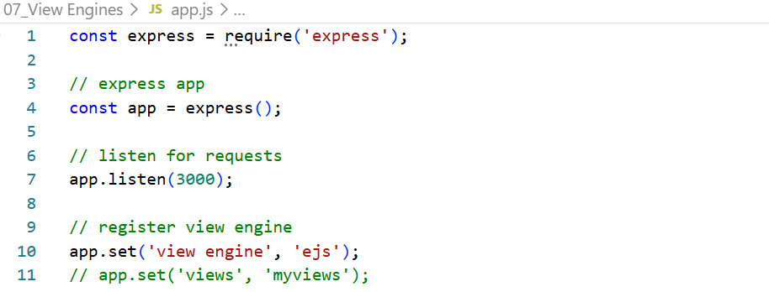

EJS looks inside the views folder for the requested template, such as index.ejs, and renders it into HTML. The same process applies to other routes and their corresponding EJS templates.
In the / route, we define a constant called blogs, which stores an array of objects. Each object contains properties such as title and snippet.
Inside res.render(), we pass the name of the EJS template (index) along with the data we want to make available to it. For example, the title property is assigned a value that can be accessed inside index.ejs.
We also pass blogs so the template can access the array of blog objects. Since the variable and the property have the same name, we can use the object property shorthand blogs instead of writing blogs: blogs.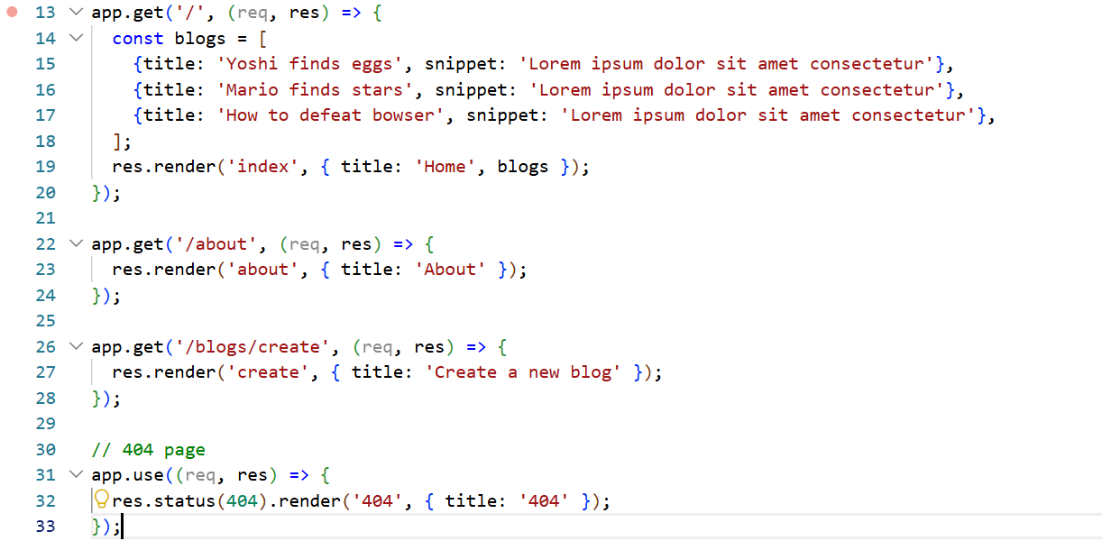
In EJS, <%, <%=, and <%- have different purposes.
Syntax | Purpose | Example
<% ... %> | Execute JavaScript without displaying its result | <% if (blogs.length > 0) { %>
<%= ... %> | Display a value, escaping HTML | <%= blog.title %>
<%- ... %> | Display unescaped output, often HTML or included templates | <%- include('./partials/head.ejs') %>
<%# ... %> | Comment; not executed or displayed | <%# This is a comment %>

First, we check the length of the blogs array. If its length is 0, we display an appropriate message. Otherwise, we iterate through the blogs array using blogs.forEach() to access each blog and display its information.
We also use the same navigation bar in index.ejs, about.ejs, and create.ejs. Since this is common code that we need to reuse across multiple templates, we create a partial containing the navigation bar to avoid duplicating the same code.
We include this partial using the EJS <%- %> tags, which render the included template's HTML without escaping it.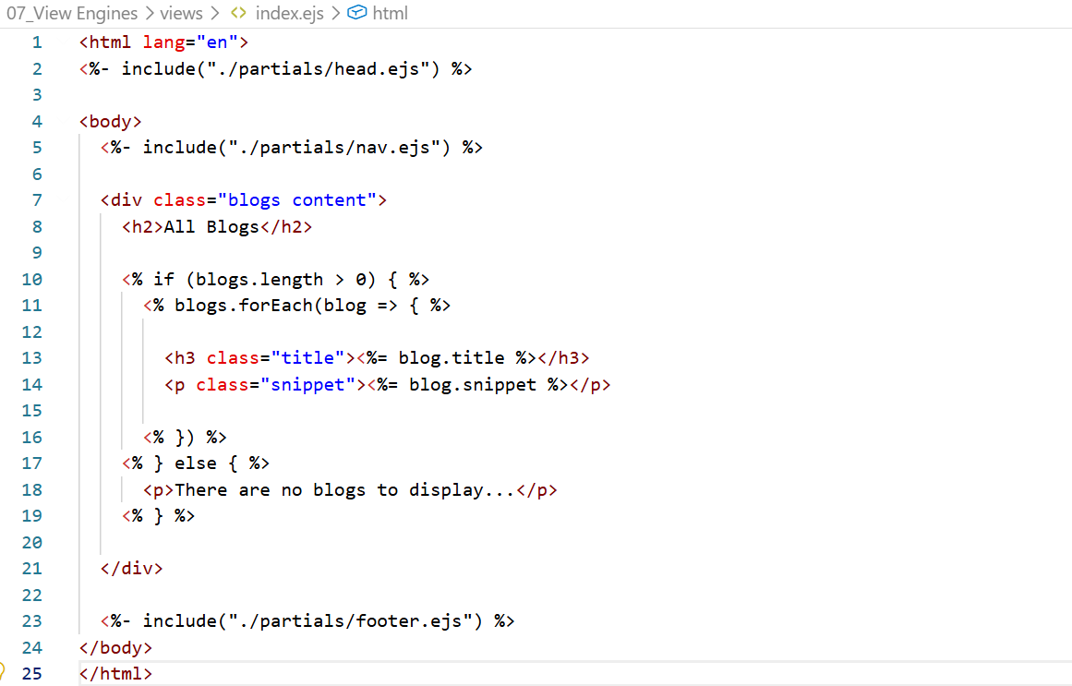
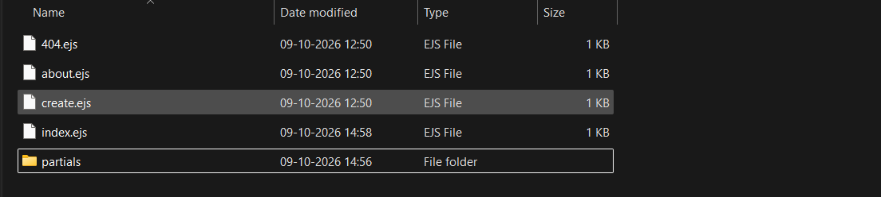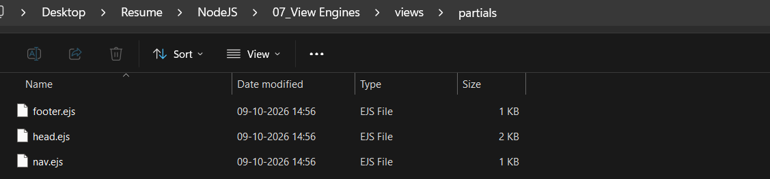
We can run the application as usual using nodemon app.js. We have also created a create.ejs page where users can enter new blog details. However, since the form is not connected to any backend logic that processes or stores the submitted data, it is not functional yet.
We use res.render() to render an EJS template. We generally just need to provide the template name, and Express will look for the corresponding file inside the configured views directory. If the file has an .ejs extension and EJS is configured as the view engine, Express will render it into HTML.

The image shows how EJS templates are converted into HTML on the server before being sent to the browser.
1. EJS template
We write HTML mixed with EJS syntax. For example: <p><%= title %></p>
Here, title is a variable whose value is passed by the server.
2. EJS view engine on the server
The EJS engine processes the template and replaces <%= title %> with the actual value provided by Express.
For example, if title = "Ninja Blog", the rendered HTML becomes: <p>Ninja Blog</p>
3. HTML output
The server sends the rendered HTML to the browser. The browser receives normal HTML, not the original EJS template or its server-side code.


